Tech-ni-Fold Spine-Creaser Installation Guide
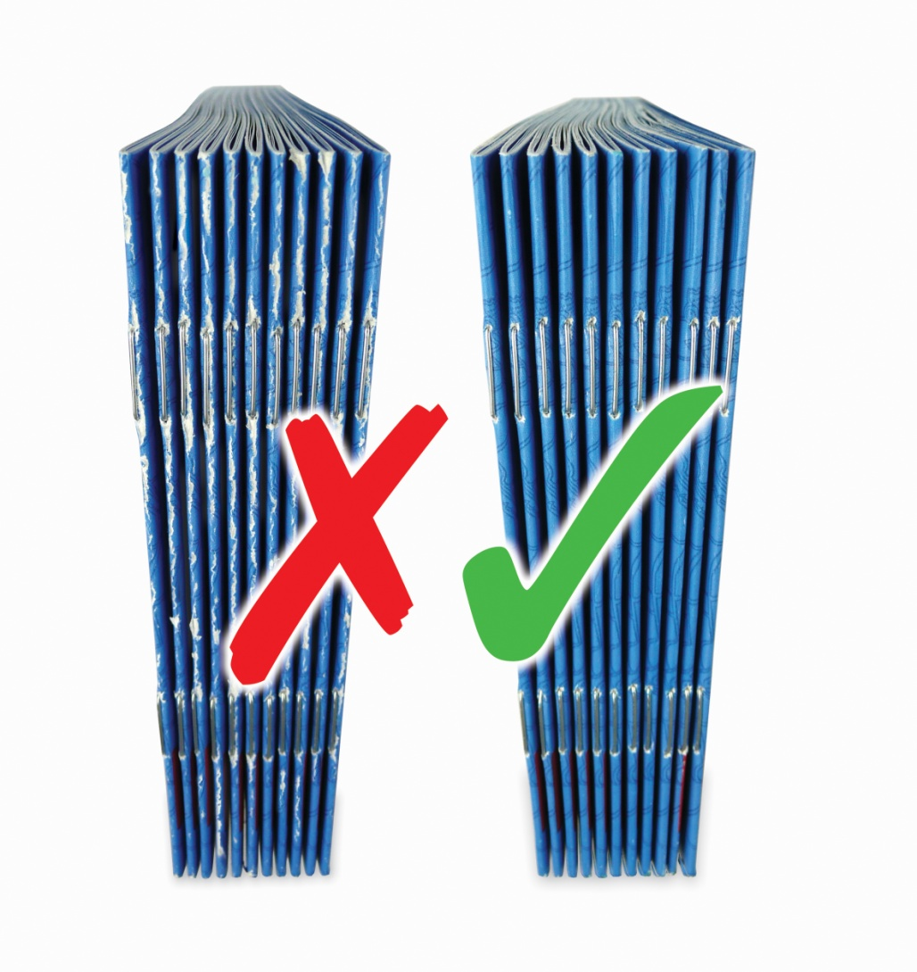
For Horizon StitchLiner MkIII Machine



WARNING
Ensure that the electrical power to the machine is switched OFF before the installation of the Tech-ni-Fold Spine-Creaser

For the Installation of the Spine-Creaser you will require the following equipment:
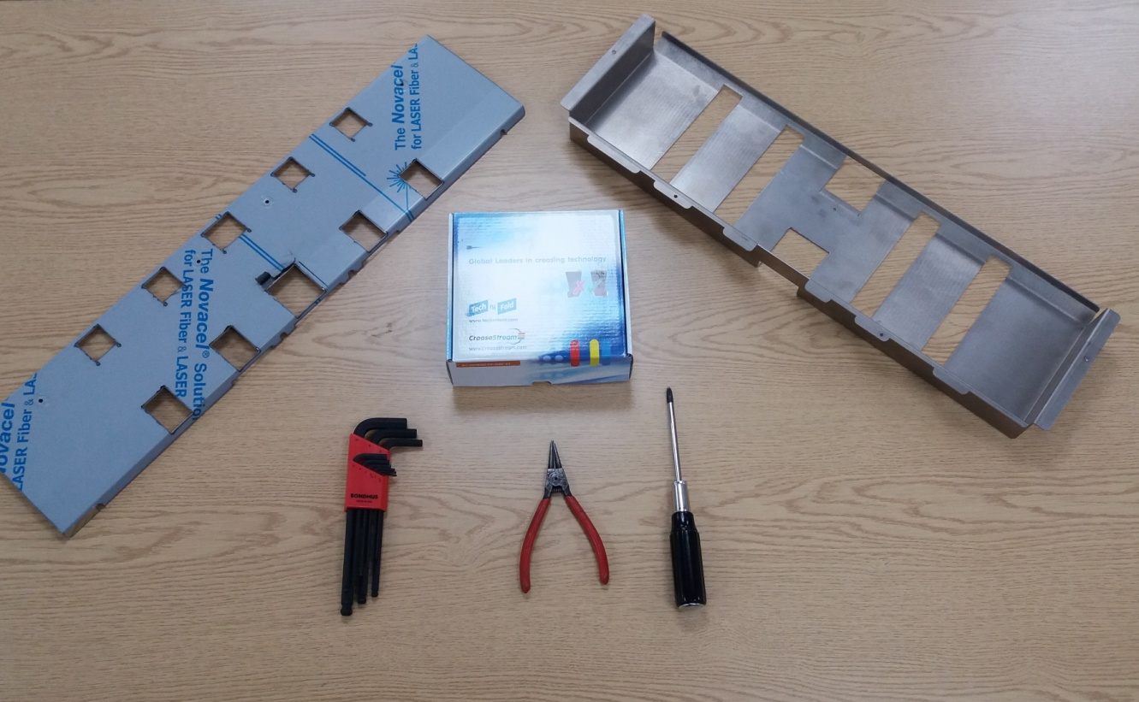
C.
F.
E.
D.
B.
A.
A. | 1x | Guide (Bottom Plate) – Horizon Part Reference: M217313-06 - *MODIFIED
B. | 1x | Upper Guide (Top Plate) – Horizon Part Reference: M217583-08 - *MODIFIED
C. | 1x | Tech-ni-Fold Spine-Creaser for Horizon StitchLiner MkIII – Product Code: SC-HOR/25-FP-DSF-01
D. | 1x | Allen Key Set
E. | 1x | Long-nose Pliers
F. | 1x | Phillips / Cross-head Screwdriver
 | 1x | Draper Disc-Cutter Multi-Tool (or other similar hand cutting tool suitable for cutting metal sheet)
 | 1x | File and Wet & Dry Paper (or some other abrasive paper)
*Regarding Modified Plates
Modified plates are not readily available at this time. All modifications are required to be made to the existing Upper and Lower Guide Plates located within your StitchLiner MkIII machine. We strongly recommend these modifications are carried out by a competent technician (see Instructions For Guide/Plate Modifications below) and ONLY when the creasing results from the Tech-ni-Fold Spine-Creaser are to the machine operators satisfaction and purchase confirmation for the Spine-Creaser tool has been agreed.

Instructions For Guide/Plate Modifications
Warning: only continue with the modifications outlined below once completely satisfied with the Spine-Creaser installation and creasing performance.

Modification to the Upper and Lower Guide (Plate) is required for the full and optimal operation of the Tech-ni-Fold Spine-Creaser.
Failure to adhere to these instructions will result in unnecessary wear and damage to the creasing components during installation, creasing component changeover and day-to-day operation.
Lower Guide/Plate
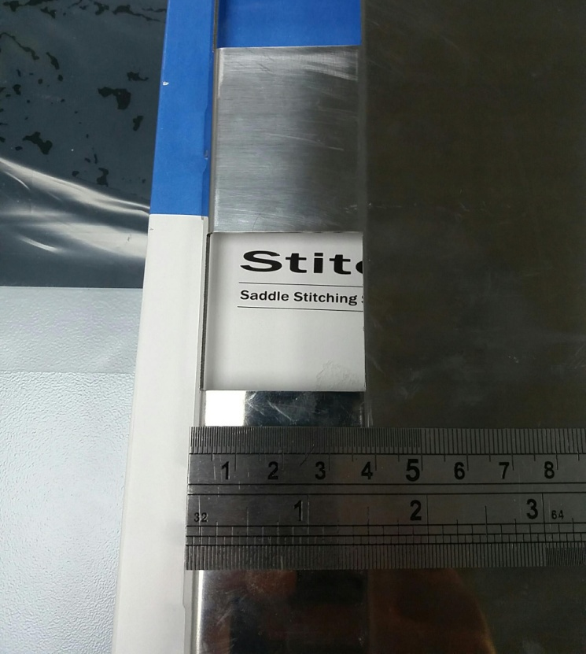
- Remove Lower Guide/Plate component entirely from machine (see Step 1, Installing The Bottom Creasing Unit)
- Place Guide/Plate securely on level work surface
- Identify centre cut out position on Guide/Plate component (this is the cut out through which the scoring unit is visible)
- Using a Disc-Cutter Tool extend the backend of the cut out by at least 5mm (see arrows for cut out extension)
- Round off the newly cut edge with a file and remove all burrs until a smooth finish is achieved
- Replace the Guide/Plate component into machine (if further room is required in this area for improved Spine-Creaser operability – make further cut out extensions incrementally)
Upper Guide/Plate
- Remove Upper Guide/Plate component entirely from machine (see Step 10, Installing The Top Creasing Unit)
- Place Guide/Plate securely on level work surface
- Identify centre cut out position on Guide/Plate component (this is the cut out through which the scoring unit is visible)
- Using a Disc-Cutter extend the backend of the existing cut out by at least 5mm (see arrows for cut out extension)
- Round off the newly cut edge with a file and remove all burrs until a smooth finish is achieved
- Replace the Guide/Plate component into machine (if further room is required in this area for improved Spine-Creaser operability – make further cut out extensions incrementally)
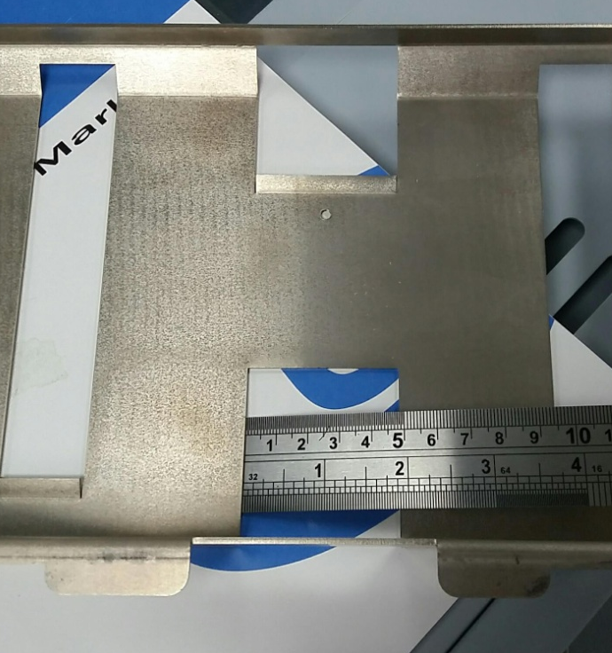

Installing The Bottom Creasing Component

1. Lift up Scoring Upper Transport Unit and remove the Lower Guide/Plate (Horizon Part Reference: M217313-06) by loosening the 4 front screws and removing the 4 back screws

2. Loosen 6 screws to remove operator-side cover (3 at top and 3 at bottom of side cover)
- Remove blue drive belt

3. Remove screws to release reverse-side cover
- Remove blue drive belt

4. Remove circlip from the centre drive wheel (3rd wheel of 5)
- Remove wheel and drive pin
- Loosen 2x 2.5mm grub screws on shaft collar and slide shaft through slightly to reveal bearing shaft collar
- Remove bearing shaft collar

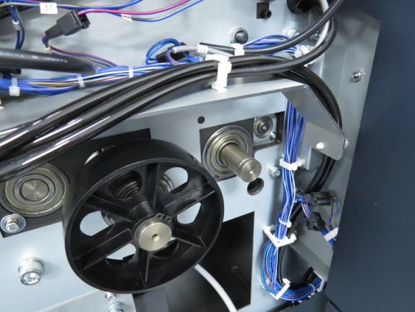

5. Push shaft through to the operator-side of machine and remove shaft entirely from machine

6. Loosen all 2.5mm screws to remove bosses and existing bottom scoring unit (from the left hand side of the shaft only; retain bosses on the right-side of the scoring unit)

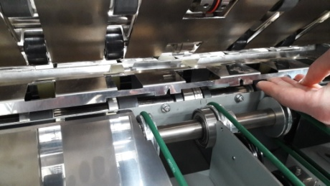

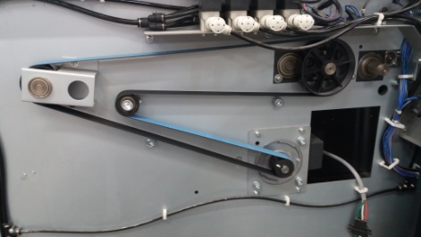
Operator-side with cover removed

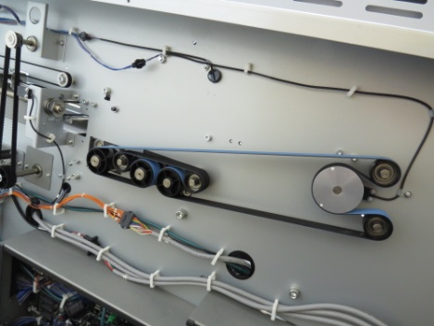
Reverse-side with cover removed
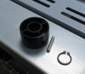
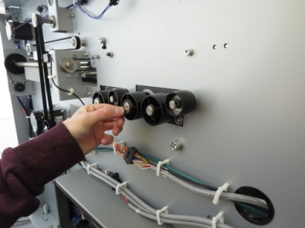

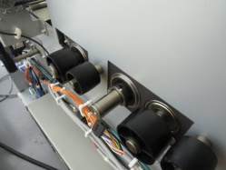

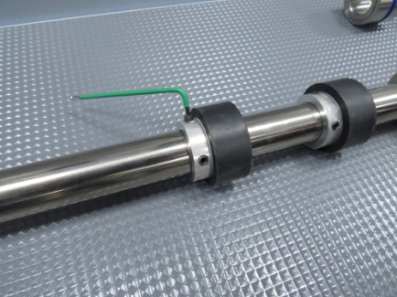
7. Install Tech-ni-Fold bottom scoring unit (ensure the etching on Tech-ni-Fold device is on the operator-side)
- Replace support bosses ensuring fixing screws are aligned with slots in shaft

8. Reverse previous steps (1-5) to reposition bottom shaft in to machine

9. Align Spine-Creaser female component to centre position of plow fold – align to green belt and use provided positioning tool (A) for greater accuracy (see image to the right)
- Place positioning tool (A) along right-side of machine framework and align the female channel with the setting mark on the tool (B) and lightly tighten 1x screw on right-side of female component to fix to shaft
- Only tighten 2nd right-side fixing screw when Male Spine-Creaser component is installed and alignment checked
- Install the modified Bottom Guide/Plate when ready (see page 2, Instructions For Guide/Plate Modifications)
- Please note: the machine can be run and tested without the Guide/Plate positioned. Do not modify the Guide/Plate until satisfied with the Spine-Creaser performance

The bottom shaft is now ready to use.

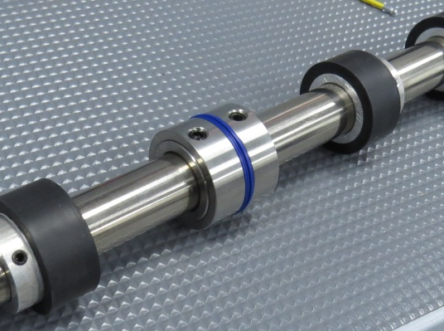

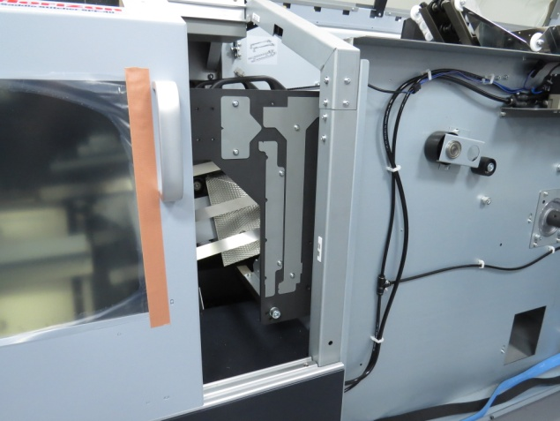
A

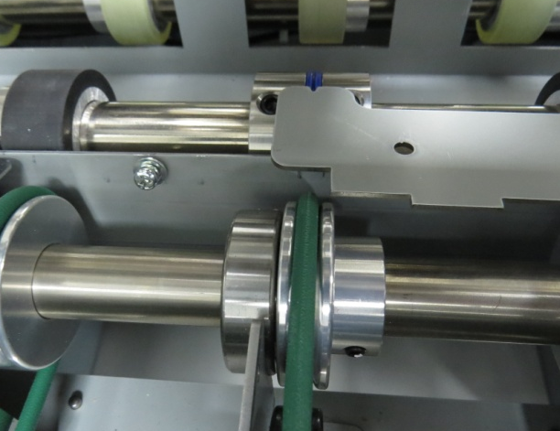
A
B

Installing The Top Creasing Component

10. Remove existing Upper Guide/Plate (Horizon Part Reference: M217583-08) by removing 10x cross-head screws around frame of Scoring Upper Transport Unit and take out plate from beneath the Scoring Upper Transport Unit

11. Remove 4x top screws on top of creasing head

12. Remove 4x 3mm grub screws from the creasing head (front & back)

13. The entire creasing head can now be removed (wiggle the creasing head side-to-side to loosen if necessary)
Note: When re-inserting the creasing head component later please ensure you replace it the same way as it was removed

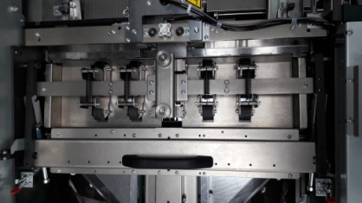

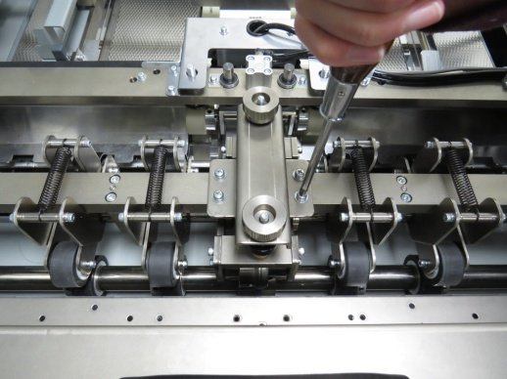

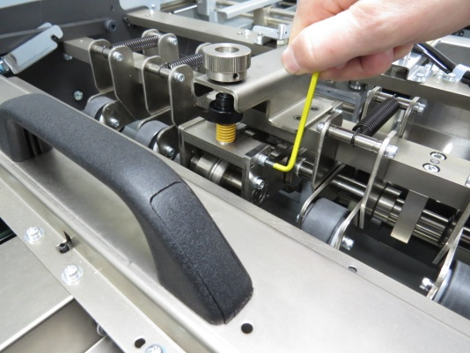

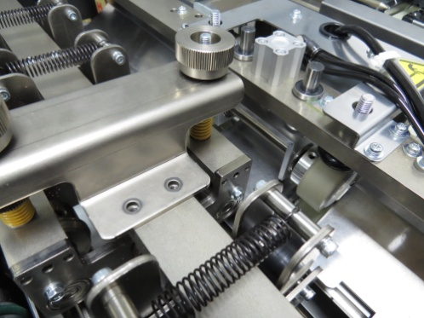

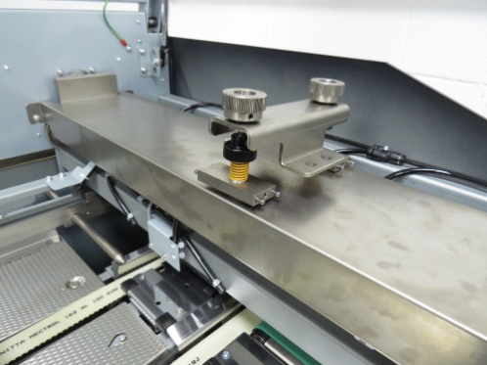

14. Remove bottom shaft sheet deflector component by loosening the 1x cross-head fixing screw with a Phillips screwdriver (the bottom shaft sheet deflector fixing screw is positioned behind the top creasing head)

15. The front mini-shaft and existing scoring unit can now slide off
- Remove existing scoring unit by loosening the 3mm grubscrew

16. Apply new Spine-Creaser Male component to mini-shaft
- Ensure Spine-Creaser shaft fixing screws are on the operator side
- Lightly tighten 1x fixing screw

17. Reverse order of steps [10-13] to reassemble the creasing head
- When re-inserting the creasing head top ensure you replace it in the same way as it was removed
- Ensure creasing head is thoroughly fixed together with all screws replaced before proceeding

18. Lift up Scoring Upper Transport Unit and insert and affix newly modified Upper Guide/Plate when ready (see page 2, Instructions For Guide/Plate Modifications)
- Please note: the machine can be run and tested without the Guide/Plate positioned. Do not modify the Guide/Plate until satisfied with the Spine-Creaser performance

19. Align Male component protrusion to the bottom Female component channel by eye
- For fine-tuning alignment, carry out procedure in step 20

20. Replace operator side drive belt
- Replace operator-side cover
Bottom shaft sheet deflector component
Sheet deflector fixing screw

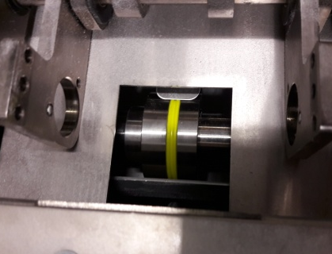
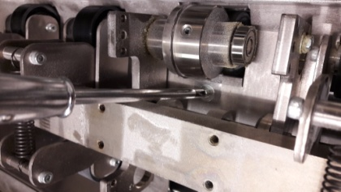

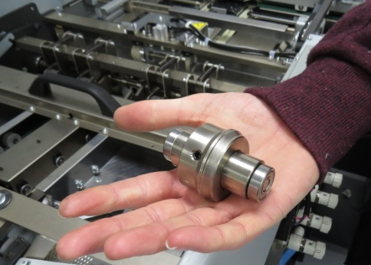

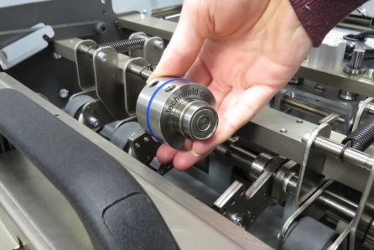

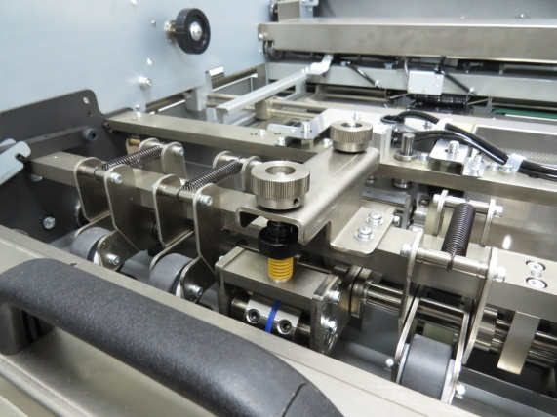

Achieving Perfect Male/Female Creasing Alignment
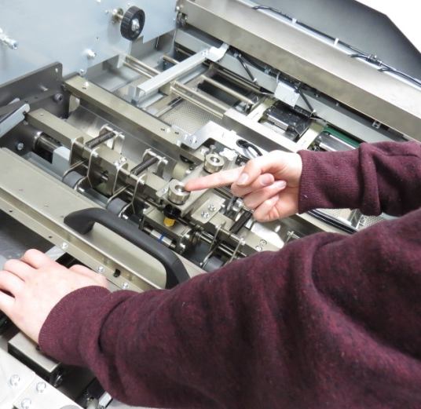
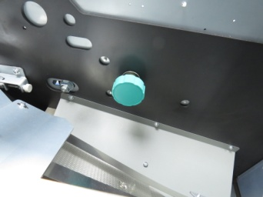
21. Wind pressure on pressure adjuster screw sufficiently so that when the green knob (shown right) is turned manually the bottom shaft rotates and drives the top component automatically
- Loosen all fixing screws at this point on the Spine-Creaser Male Component only

22. Insert a sheet of heavy stock (250-300gsm) through the scoring transport unit and advance the bottom shaft manually. This process gently pushes the top Male component into the optimum creasing position
- Tighten 1x fixing screw on the top Male Component as it becomes accessible whilst the stock is still in the machine (you may need to apply downward pressure with a free hand on to the creasing head plate when tightening the fixing screw)

23. Lock down red handles to close the creasing section lid

24. REMEMBER – maximum crease results can only be achieved when:
- the Male Creasing Component is centred correctly in the Female Receiving Component of the Tech-ni-Fold Spine-Creaser system, and:
- The Spine-Creaser system is aligned to the Horizon metal scoring tool (see ideal crease result right) and the plow folding position

25. When satisfied with crease position and Male and Female alignment, tighten all remaining Top and Bottom fixing screws on your Tech-ni-Fold Spine-Creaser

The machine is now ready to run.

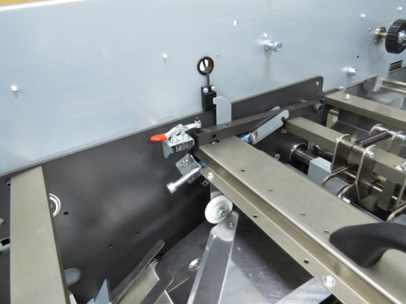

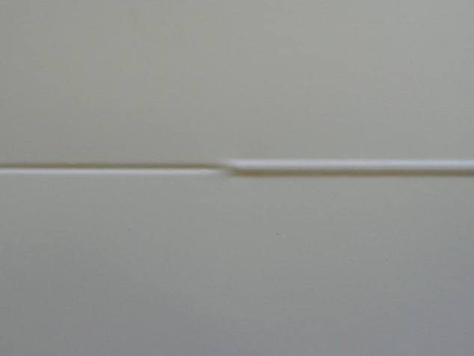

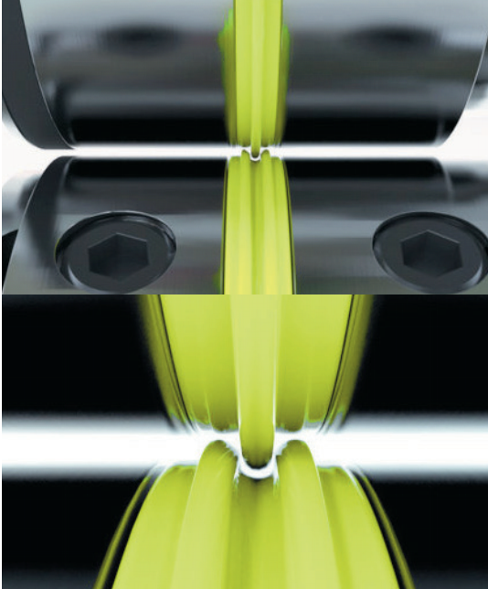
Achieving Optimal Crease Performance
The Spine-Creaser comes pre-set and ready to attach to the StitchLiner MkIII machine.
- Each coloured creasing rib set (Split Gripper Crease and Female Receiver Ring) has a unique profile to produce the relevant depth of crease required for the weight of stock that is being processed.
- To achieve the desired crease width and depth simply study the sample guide and select the correct coloured creasing setup.
- To ensure continued optimal crease performance, ensure the creasing rib set (Split Gripper Crease and Female Receiver Ring) is checked before commencing any creasing operation. Wear and tear of the creasing set will occur after some time. Excessive wear of these parts will reduce creasing performance. It is recommended these parts are checked and replaced as necessary.
Crease Style Sample Guide
85 – 150gsm combined weight
150 – 250gsm combined weight
250 – 500gsm combined weight
500 – 700gsm combined weight

Interchangeable Top & Bottom Creasing
Using your Tech-ni-Fold Spine-Creaser you can quickly and easily change crease direction by simply interchanging the Male Creasing Rib and the Female Receiver Ring.

A

To install or remove the creasing inserts loosen screw (A) and slide locking collar away from insert. The split insert can now be removed/installed.
The small Extraction Tool is supplied to aid the removal of the creasing inserts.
IMPORTANT NOTES:
The Tech-ni-Fold Spine-Creaser is designed to produce a sensitive creasing application on multiple stock layers and difficult digitally printed stocks.
We guarantee the elimination of fibre-cracking on combined stock weights up to 400gsm, but on many print/paper combinations fibre-crack free results can be achieved up to 700gsm.
The two-way creasing application means that both the top- and under-side of the stock is creased simultaneously.
Wear and tear will occur to the creasing components over time.
The creasing components (Split Gripper Crease and Female Receiver Ring) should be checked regularly and replaced as necessary to maintain optimal crease performance.

